Numbers 35 The Hiding Place

Read Numbers 35

The background

After giving the instructions on distribution of the land in Canaan, Moses now approaches a special group of people. Do a brief review on the background of the Levites (we have done it before, so should be quite straight forward).

Read Genesis 34, do a quick summary of the incident:

What happened to Dinah?

Who responded to Dinah? What did they do?

Was the response appropriate? What about the methods used?

What were the consequences?

What did Levi and his descendants deserve?

Was the curse fulfilled? How was it fulfilled for Simeon? What about Levi?

Follow through the following texts, what do you think is the “good” that has come out of the curse?

Genesis 49:7

Leviticus 10:11

Deuteronomy 31:9013; 33:10

The central idea of the Levites (which included the priests) not having a physical inheritance was to teach them and the Israelites the idea and privilege of having God Himself as their inheritance. Discuss among your group what does this would mean in practice? [Bonus: considering 1 Peter 2:9, what do you think this would imply for Christians today?]

City of Refuge (Verses 9-15)

How many special cities of Refuge were to be set up?

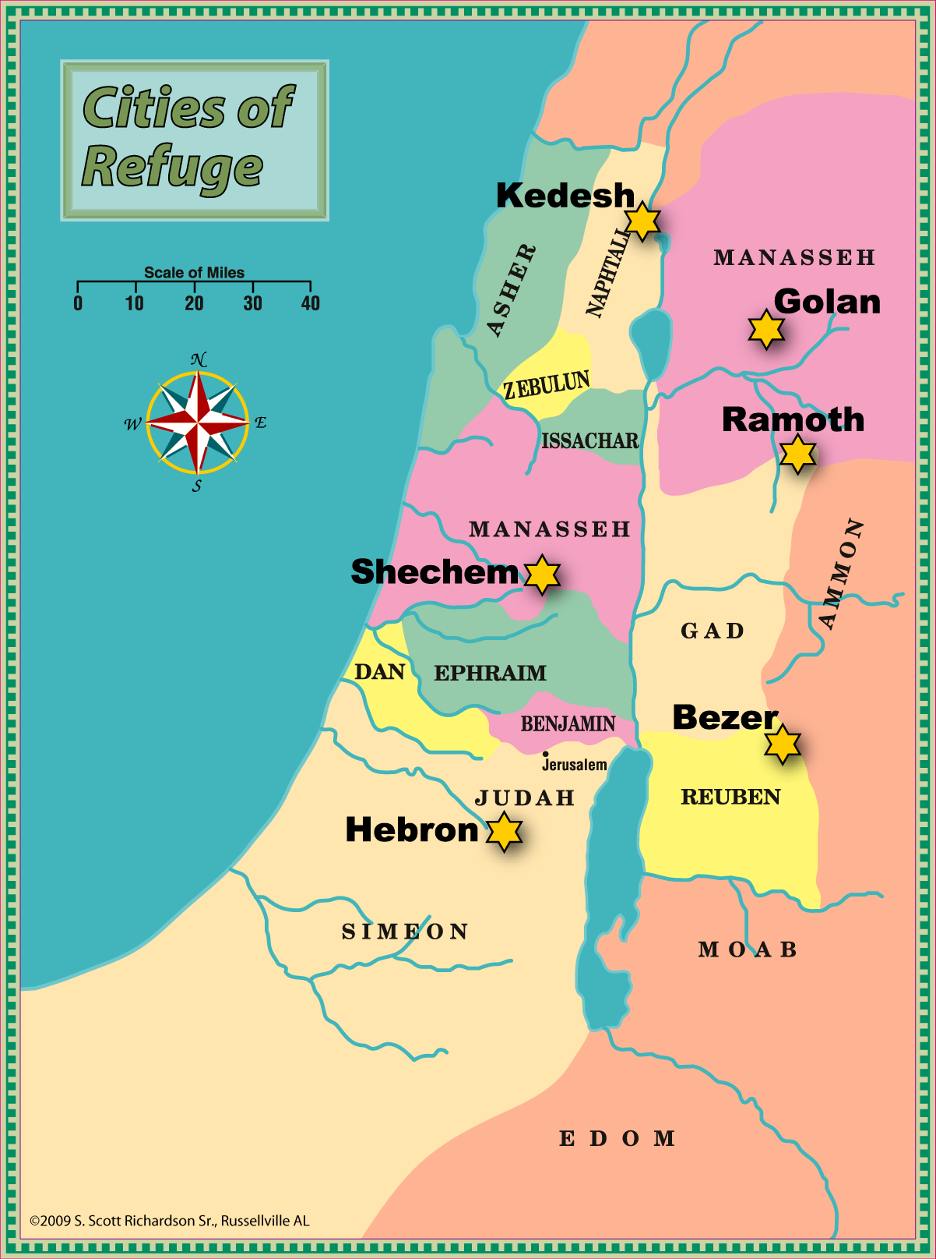
Look at the diagram on the left marking out the location of the cities of refuge. Can you give a plausible reason for their choice of locations? (Note that the original law for handling manslaughter is given in Exodus 21:12-14; would that help your answer?)

When you read a passage like this (Numbers 35) what can you gather from this passage on the following:

God’s attitude towards human life:

Scripture’s perspective on punishment? (Clue: what do you think the word retribution mean?)

Judgement and mercy verses 16 to 34

The word ‘manslaughter’ simply mean someone who took another person’s life.

Here in Numbers 35:9-15, a distinction is being made. Can you highlight the two cases?

Situation 1:

Situation 2:

What’s the verdict concerning situation 1? Read verses 16 to 19; then read 31 to 34; what do you think is the concern here? What does that tell you about God?

For situation 2, there is a case for mercy! Can you identify the various provisions in verses 16-34?

Provision 1 (verse 24):

Provision 2 (verses 25, 30):

Provision 3 (verses 25, 28):

Note the condition for the preservation of mercy (verse 26):

A quote:

“Once again, don’t miss the irony of the fact that these cities of refuge were Levitical cities. Remember what it was that had cause Levi to be placed under a curse; it was the act of murder! Had God carried through on Levi the sentence he mandated here, there would have been no Levites at all. Every time his descendants witness a trial that resulted in death for the murderer and the internal exile for the manslayer, they would be reminded of the grace they had received. As they were required to provide hospitality for the manslayer, they had the opportunity to show to others the outworking of that same grace.”

Note on Avenger of Blood as given in verse 12:

Avenger (gō’ēl). Although this translation fits the present context, the basic meaning of the term gō’ēl is “near kin,” and refers to the person chosen by a family to deal with a loss suffered by that family. The gō’ēl does not engage in revenge, but in redemption of family loss, and thus comes to mean “redeemer.” The duties of the gō’ēl may be to contract Levirate marriage (Ruth 3:13), to receive money payable to a dead family member on behalf of the family (Num. 5:8), to buy a family member out of slavery brought on by poverty (Lev. 25:48), to buy property that has passed out of the family under similar conditions (Lev. 25:25), or to buy property to keep it from passing out of the family (Jer. 32:7–15). The gō’ēl may also restore the loss a family has suffered when a member has been killed. When such becomes the task of the gō’ēl, the usual term is “avenger of blood” (gō’ēl-haddām), as in vv. 19, 21, 24–25, 27.

Conclusion and summary

Can you see Christ in each of the provisions mentioned in this chapter?

Avenger of blood:

City of Refuge:

High priest:

Question for meditation:

How would a chapter like Numbers 35 be useful for me, a believer in the 20th Century in Singapore?

Numbers, God’s presence in the wilderness; Iain M. Duguid pp359-360. Preach the Word series by Kent Hugh. Crossway publisher.
Ashley, T. R. (1993). The Book of Numbers (pp. 650–651). Grand Rapids, MI: Wm. B. Eerdmans Publishing Co.

